1. List all functions from a 2 element set to a three element set
   1. S = {a , b} ;T = {1 , 2 , 3}

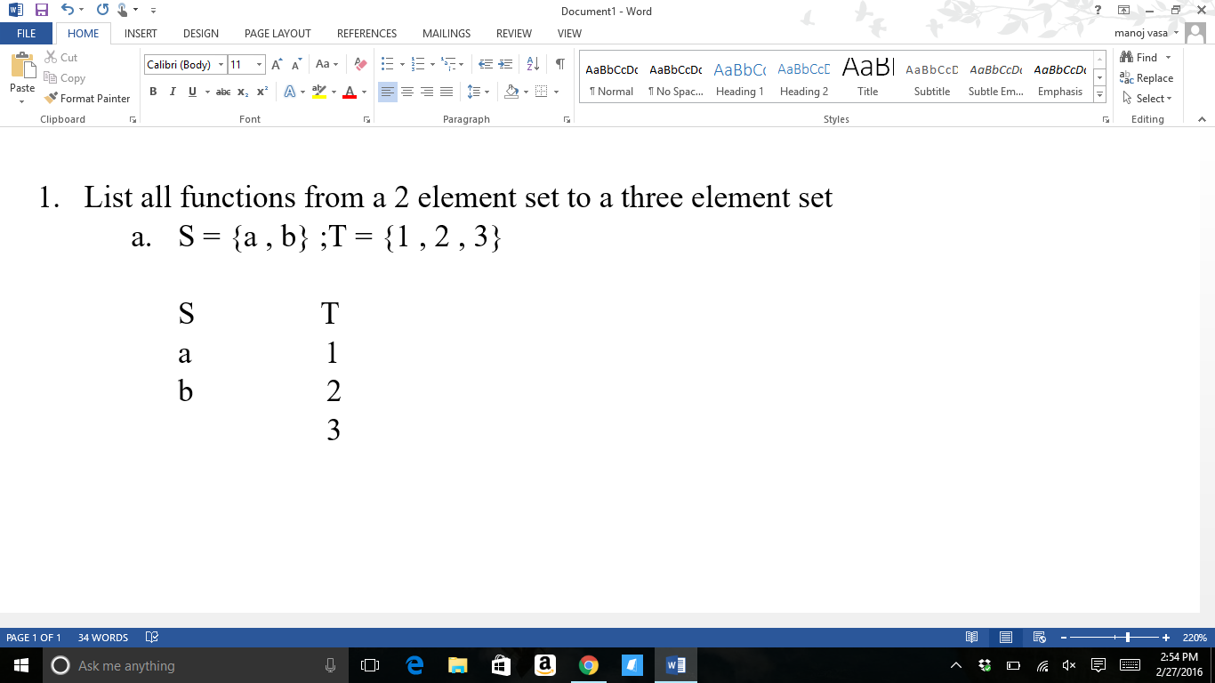





The folowing digraphs show in order all the possible relations from set S to set T where each row represents all the possible relations of b when a is assigned a constant value. For example, for the row one we see the possible relations of the b element in Set S to the elements in Set T when a is only directed towards 1. For the row two we see the possible relations of the b element in Set S to the elements in Set T when a is only directed towards 2. Furthermore, for row three we see all the elements b is directed to as a is only directed towards the element 3 in set T. This allows for us to list all the possible functions without missing any possible relations as we can see the clear opposite relations of the previous explantion when we view each column where b is directed towards one value while a is directed towards the others for each column.

* 1. Label the functions
     1. The function {a1, b1} is neither a 1 – 1 nor onto function since both elements of set S are directed to the same value. For a function to be 1 – 1 all values of set S must be directed to at most one unique element of set T.
     2. The function {a1, b2} is a 1 – 1 function but not onto since there are no arrows pointing to the element 3 in set T, but each element of set S is directed to a unique value in set T. That is no more than one element of S is directed towards the same element of T.
     3. The function {a1, b3} is a 1 – 1 function but not onto since there are no arrows pointing to the element 2 in set T, but each element of set S is directed to a unique value in set T.
     4. The function {a2, b1} is a 1 – 1 function but not onto since there are no arrows pointing to the element 3 in set T, but each element of set S is directed to a unique value in set T.
     5. The function {a2, b2} is neither a 1 – 1 nor onto function since both elements of set S are directed to the same element in set T.
     6. The function {a2, b3} is a 1 – 1 function but not onto since there are no arrows pointing to the element 1 in set T, but each element of set S is directed to a unique value in set T.
     7. The function {a3, b1} is a 1 – 1 function but not onto since there are no arrows pointing to the element 2 in set T, but each element of set S is directed to a unique value in set T.
     8. The function {a3, b2} is a 1 – 1 function but not onto since there are no arrows pointing to the element 1 in set T, but each element of set S is directed to a unique value in set T.
     9. The function {a3, b3} is neither a 1 – 1 nor onto function since both elements of set S are directed to the same element in set T.
  2. You can count the number of functions between the two sets by forming a systematic digraph that lists all the possible relations of those elements in the two sets. No two of these digraph functions should be the same. Listing out all the digraphs gives you all the functions.

1. 4 scoop ice cream cones with a 9 available flavors.

Stacks: S = {1, 2, 3, 4}; Flavors: F = {a, b, c, d, e, f, g, h, k}

S F

a

b

c

d 1

e 2

f 3

g 4

h

k

* 1. Flavors can repeat and order matters. The computation:

(9\*9\*9\*9)(4\*3\*2\*1) = 157,464 combinations

Gives us the answer. Given the fact that flavors can repeat allows us to use as many flavor for the next stack as the one before. In other words, each stack has the possibilty of nine flavors. However, the order of these flavors does matter, so the 4! accounts for this situation. The 4! allows for us to count for all the possible ordering of the flavors as each flavor can repeat or be in any of the four stacks.

* 1. Flavors cannot repeat and order doesn’t matter: 9\*8\*7\*6 = 3,024 flavors

The flavor that is already stacked onto the cone cannot be repeated for the next stack. This means that the first stack has 9 possible flavors and this first flavor is excluded for the next stack and the one following giving the next stack 8 possible flavors. The flavors of the two previous stacks are excluded for the third stack giving this stack 7 possible flavors, and the last stack has 6 possible flavors as the flavors from the other stacks are excluded for this stack. This reasoning gives us 9\*8\*7\*6 = 3,024 possibilities

* 1. A and B both relate to counting functions because we are mapping a nine element set to a four element set. This mapping establishes the number of functions that we can establish with the given conditions. Each of these functions is a possibility for the number of combinations available. So, counting these possible variations is also like counting functions.

1. 10 women, 12 math majors, and 7 people over six feet tall
   1. There isn’t enough information to tell how many people are in the class. Given this information we wouldn’t be able determine if the different categories of descriptions overlap or aren’t related at all. For instance, there could be 10 women, 12 math majors, and 7 people over six feet tall with a total of 29 people. However, all ten of these women could be math majors and six feet tall reducing the amount of people in the class. Hense, we need more information as to which of these students fall into which category. Each of these students/people could have more than one of these traits or only one trait. There is no way to tell for sure with the lack of information.
   2. If six of the math majors are women, we know that there are 6 more math majors of whom aren’t women and and 4 women that aren’t math majors. Excluding the fact that there are 7 people that are over six feet tall we’d then be able to conclude that there are a total of 16 people. However, we still don’t have enough information to conclude how many people there are in the class due to the lack of information on the final trait. We know how many people are over 6 feet tall, but we don’t know if those seven people include the women math majors and other math majors, just the women, or if those 7 people are not women nor math majors. We don’t have enough information to tell which of these seven people are over 6 feet tall. So, we still don’t have enough information to determine the total number of people in the class.
   3. Yes, I would be able to tell how many students are in the class if I was given this piece of information:

6 women math majors

6 more math majors that aren’t women

4 women

Given this information we know that there are a total of 16 students in that class and of those 16 students 7 are over 6 feet tall given that that all the people in the class are students. If we were told that all the people in the class were students to begin with, we’d have no doubt about the number of students in the class given this information. There is the possibility, however, that some of these people may be professors or even just visitors. Assuming that all the people in the class are students and only students we can say that there are 16 people in the class plus the student that just walked in.

1. [9] = [1,2,3,4,5,6,7,8,9]
   1. Two partitions of 9 are:
      1. [1,3,5,7,9],[2,4,6,8]
      2. [1,2,3,4],[5,6,7,8,9]

A partition is all the ways in wich a Set S can be devided into. Where each partition has elements of A that don’t repeat in or within other partitions.

* 1. [{1},{2},{3},{4},{5},{6},{7},{8},{9}, {1,2},{1,3},{4,5},{1,9}] are some distinct subset of [9]. These subsets fail as a partition due to the fact that they don’t represent the sets of divisions of the element of [9] where no element repeats in each of there divisions and in other divisions. These subsets however, show the representation of the set [9] with repetition of values throughout the representation.

1. I partitioned the functions to where all the sets consist of the same number of individual functions. Each set of functions consists of 3 individual functions and allows us to compute the whole number of functions by computing 3 \* 3 = 9.
2. Count all the functions from {1,2,3} to {a,b,c,d}. student listed them as (1,a), (1,b)…
   1. This is not a reasonable way to list all the functions. Listing like this doesn’t satisfy the neccessisities for the relation to be a function. The student’s list by definition is not a function due to the case that he isn’t showing the mapping from the rest of the elements of the three element function to the other set. Let the three element set be the inputs and the four element set be designated as outputs. I would ask the student at least and at most how many outputs there must be for each input for the mapping to be a function.
   2. A better way of listing the functions would be by doing it this way:

(1,a), (2,c), (3,a)

(1,a), (2,c), (3,b)

(1,a), (2,c), (3,c)

(1,a), (2,c), (3,d)

(1,a), (2,d), (3,a)

(1,a), (2,d), (3,b)

(1,a), (2,d), (3,c)

(1,a), (2,d), (3,d)

(1,a), (2,a), (3,a)

(1,a), (2,a), (3,b)

(1,a), (2,a), (3,c)

(1,a), (2,a), (3,d)

(1,a), (2,b), (3,a)

(1,a), (2,b), (3,b)

(1,a), (2,b), (3,c)

(1,a), (2,b), (3,d)

And so on…

The list above is a far more organized list that lets us see a pattern which will allow us to compute the number of functions without listing out all the rest of the functions. In this list, I made it so that all the functions have the assigned value of 1a as one of the relations. This lets us see all the possible functions when 1 is only mapped to a. Furthermore, the next list would comprise of the same mapping for the element 2 and 3, but the element 1 is only mapped to b for all the functions. This also applies to when 1 is mapped to either c or d. Given this information we can see that there are a total of 64 functions with 16 functions with the constant relation of 1a, 16 of 1b, 16 of 1c, and 16 of 1d.

* 1. A better way to count the functions is to construct a digraph that allows us to see all the relations between both the 3 element set and the 4 element set at the same time. Being able to see that 1 can be mapped to 4 elements, 2 can be mapped to 4 elements, 3 mapped to 4 elements makes it easier to recognize number of functions.

S = {1,2,3} T = {a,b,c,d}

S T

1 a

2 b

3 c

d

As we can see in the digrah above there are four ways in which each of the elements in S can go to an element in T. So computing the number of functions this way will give us 4\*4\*4 = 64. This is the same answer we got with the previous method, but that method would’ve taken a significantly longer time to reach the answer.

1. 140 seats in the auditorium and all of them are full.
   1. The bijection principle is true if the onto principle and one-to-one principle are not violated. Let S be mapped to T where S are inputs and T are outputs. The one-to-one prinicple states that for every input there is to be at least and at most one output. In other words, for every S there must be only one T. The onto principle states that for every output there must be at least one input.

From the one-to-one principle we can tell that if all 140 seats in the auditorium are filled that there must be at least and at most one person for each of those seats. With the application of the onto principle we can determine that if the only people in the auditorium are the people seated then the number of people in the auditorium is the number of people seated since there can’t be any more people in the auditorium that exceed the number of seats. If there are more people then the onto principle is violated. There are 140 people in the room.

1. Number of functions from [n] to {0,1} is the same as the number of subsets of [n]

Let the set be defined to be [3] = [1,2,3]

Subsets of [3] = [empty set 0, {1},{2},{3},{1,2},{1,3},{2,3},{1,2,3}

Functions from [3] to {0,1}

S = [1,2,3] T = {0,1}

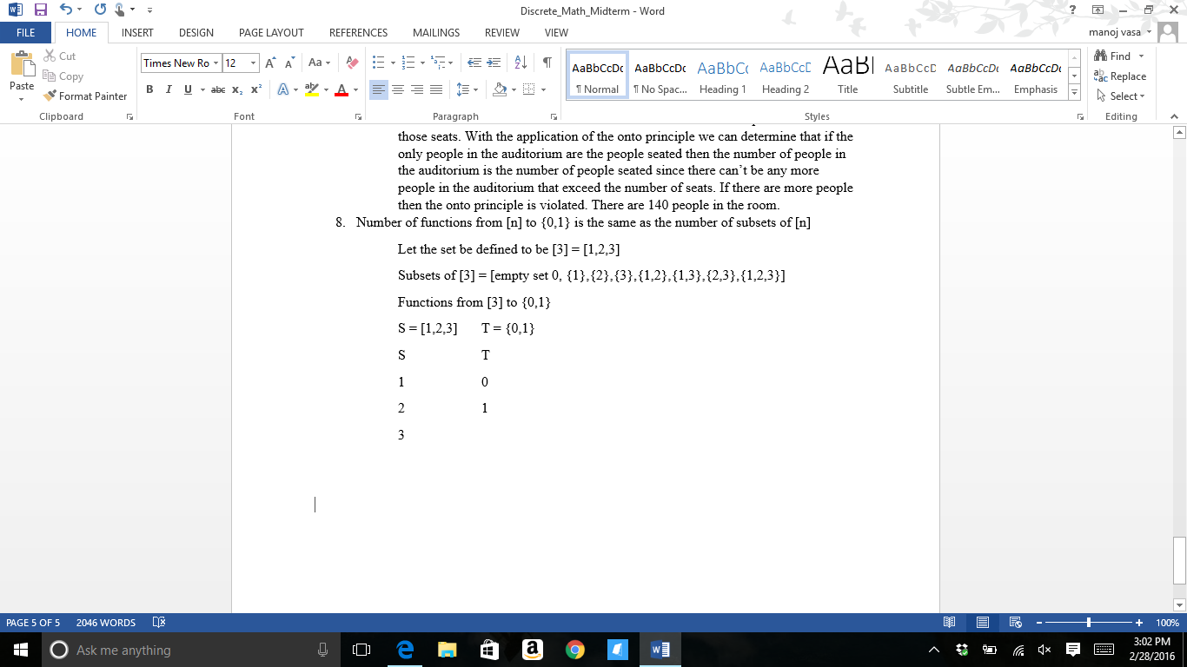





Above I’ve provided an example for when n is 3. This has shown that the elements in T (1 and 0) can act as a characterization function for the representation of all the subsets of n. As determined by the functions from [n] to {0, 1}, the elements in n either belong (1) or don’t belong (0) according to the elements of T. Such a characterization from the mapping describes the subsets of [n]. That is why there is a one-to-one and onto correspondence between the element of the subsets of [n] and the functions from [n] to {0, 1}. The functions are a definition of each subset of [n] where an element of [n] is either in the subset or not.

1. You’d need at least 32 in a class to guarantee that at least two of them will share a birthday. This is the case due to the pigeonhole principle. If there are 32 people and somehow the first 31 people in the class all have unique birthdays, then the 32nd person must share a birthday with at least one of those other people since all the dates are already occupied.
   1. You’d need one element less than the amount of elements in the co-domain. After all the elements in the domain are mapped to the co-domain, there’ll be one more element in the domain that still needs to be mapped to the co-domain. So, the function can’t be one-to-one.